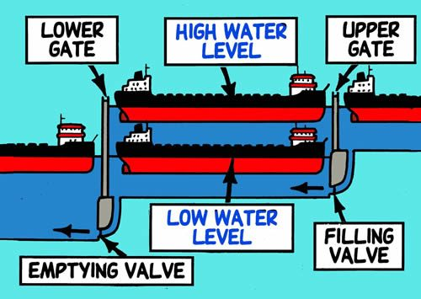<https://theprogressivecynic.com/2014/06/12/the-us-distribution-of-wealth-is-like-a-canal-with-broken-locks/>

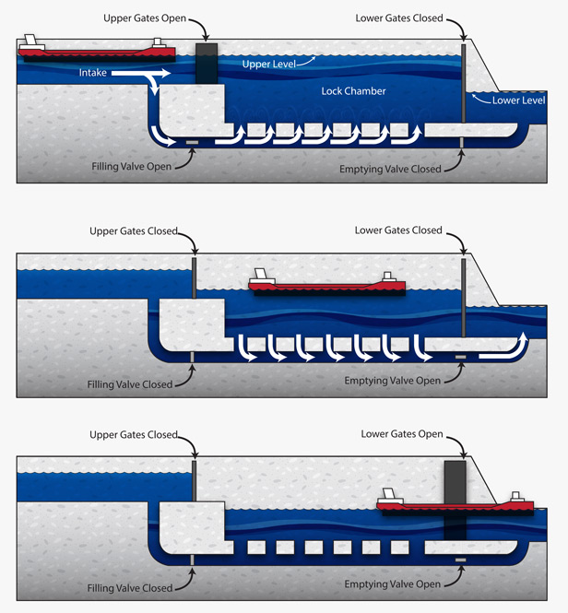

<https://gearpatrol.com/2015/06/05/the-soo-locks/>



<https://www.seattletimes.com/seattle-news/politics/ballard-locks-they-dont-move-a-lot-of-freight-but-they-mean-a-lot-of-money-and-need-repair/>

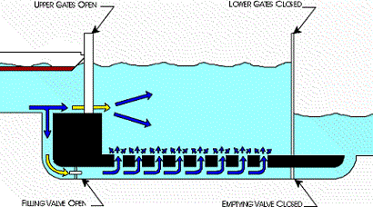

<https://www.google.com/imgres?imgurl=https%3A%2F%2Fteachengineering.org%2Fcontent%2Fcub_%2Flessons%2Fcub_dams%2Fcub_dams_lesson03_animation1web_new.gif&imgrefurl=https%3A%2F%2Fwww.teachengineering.org%2Flessons%2Fview%2Fcub_dams_lesson03&tbnid=Jz2vaoIj557s6M&vet=10CBEQxiAoAmoXChMIuOaJq-aF6QIVAAAAAB0AAAAAEAo..i&docid=ReT7swKAZd_YCM&w=410&h=228&itg=1&q=paddle%20water%20lock&ved=0CBEQxiAoAmoXChMIuOaJq-aF6QIVAAAAAB0AAAAAEAo>

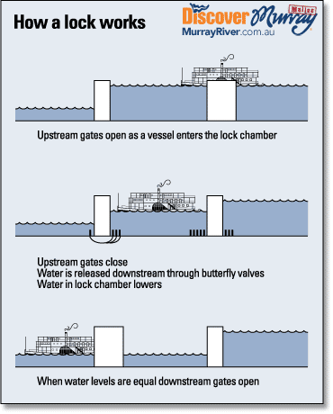

<https://murrayhouseboatholidays.com/about-the-murray-river/locks-and-weirs-of-the-murray/>

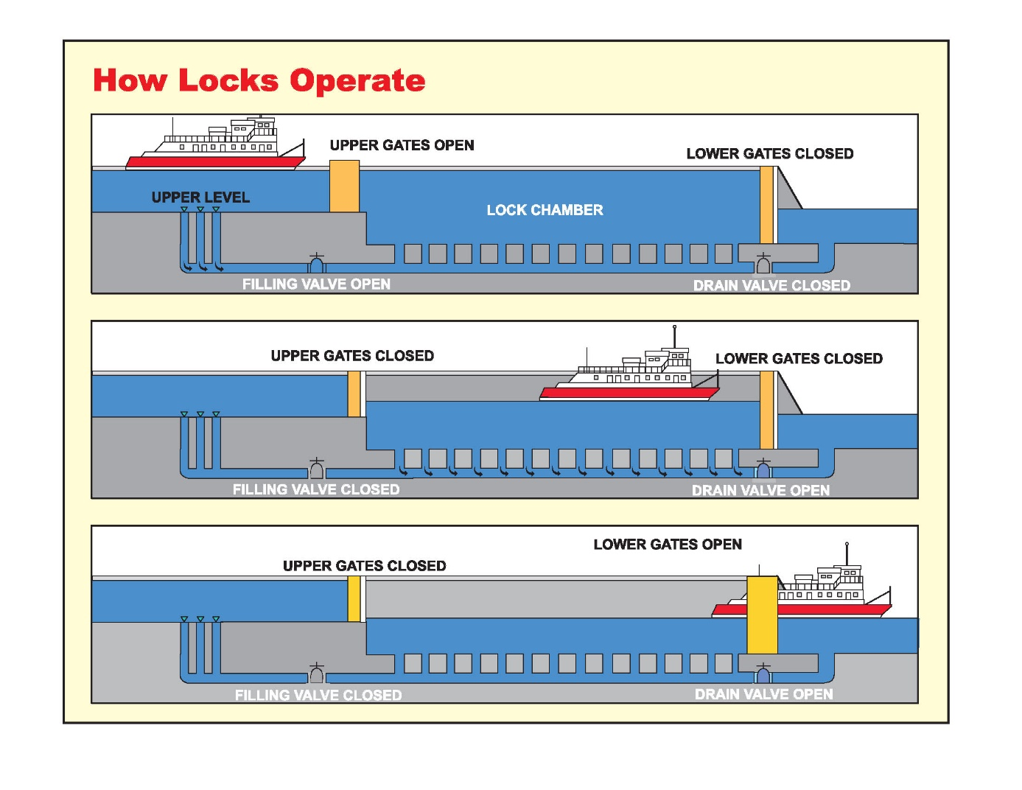

<https://www.lrl.usace.army.mil/Portals/64/docs/Ops/Navigation/lockthru.jpg>

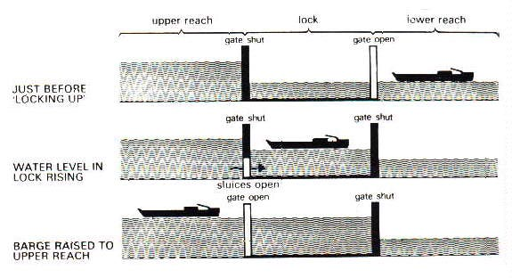

<https://blogitecture.weebly.com/project-2/canal-systems>

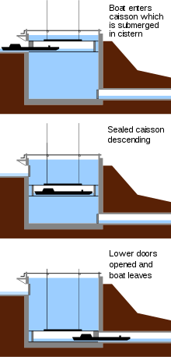

<https://en.wikipedia.org/wiki/Lock_(water_navigation)>



<https://giphy.com/gifs/canal-GTq7cSRRcS2dy>

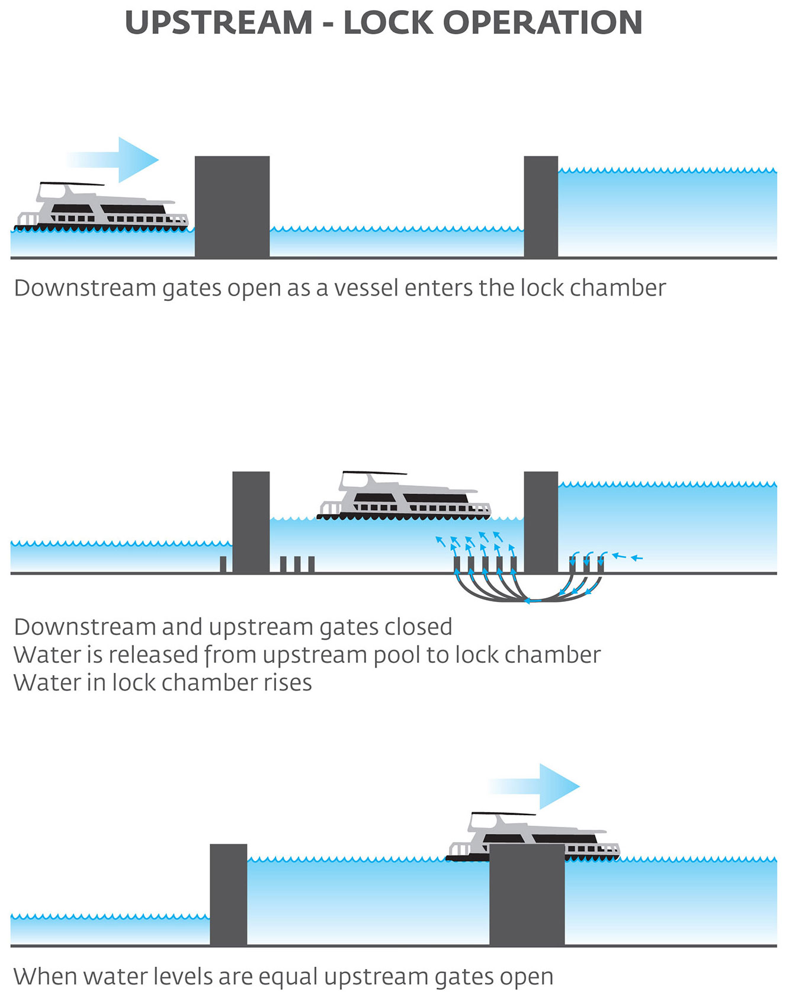

<https://www.sawater.com.au/community-and-environment/the-river-murray/lockages>

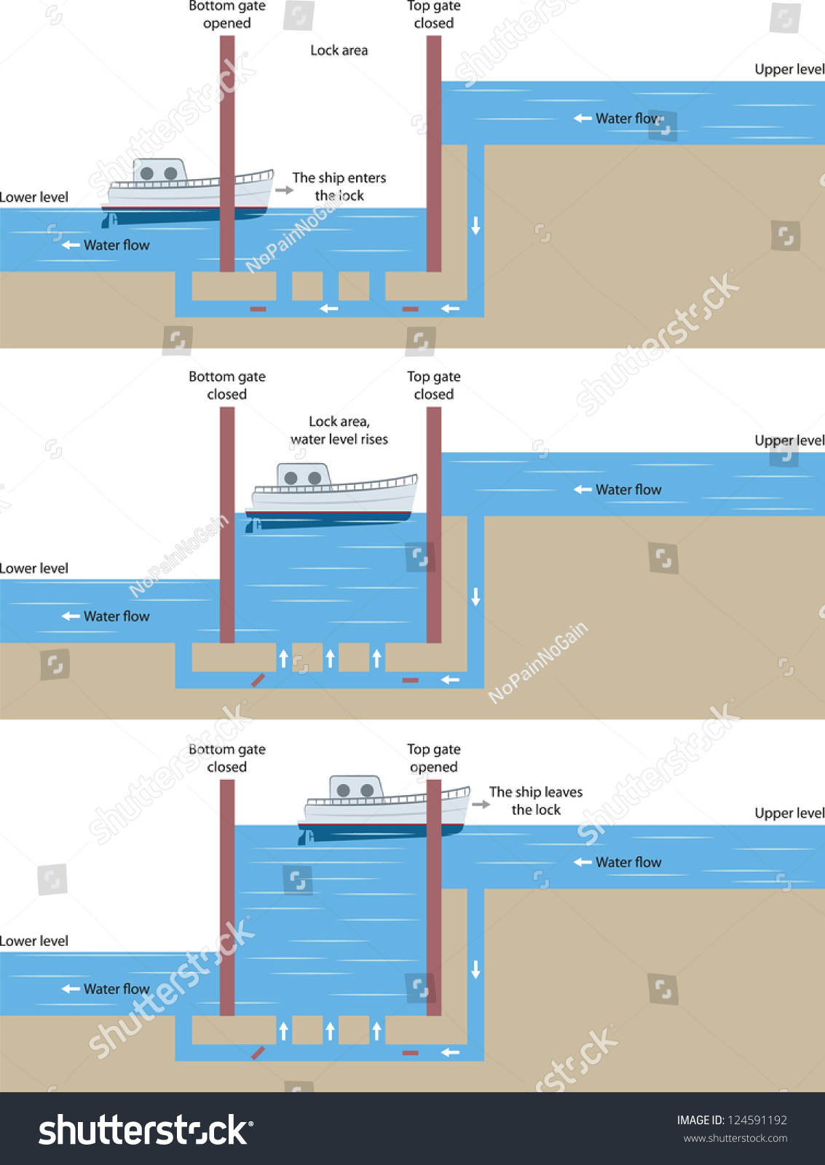

<https://www.shutterstock.com/nl/image-vector/principle-operation-ship-pound-lock-124591192>

#@ZOO^^St@ts vorSCORO20@20

<http://narrowboatingforbeginners.com/wordpress/locks-bridges-and-tunnels/>

<https://www.abcboathire.com/more-information/a-guide-to-operating-locks>

<https://en.wikipedia.org/wiki/Lock_(water_navigation)>